Project 4: File Management System

CST-315-99 (Operating Systems)

Cameron Verini

12/4/2022

**Project Description:**

Within this project, we were tasked with updating our program from our previous projects by adding in a file system manager that is capable of creating, removing, moving, renaming, editing, and displaying information for files and directories.

**Methodology/Approach:**

The most valuable function in the code is the “system()” function. The “system()” function is a function that is included in the default packages for C++ that interprets the inputs for the program and runs the corresponding executions in Linux for us. With this function, it is very easy to allow the use of standard Linux commands in the program. Considering that Linux commands already exist for all of this project’s requirements, this is all that was needed to complete it.

**Implementation:**

The code that was required for this project has actually been implemented since the first project. Though many other improvements and new additions have been made, the general structure and function that interprets the commands that the user inputs has not changed.

**Test and Validate:**

Creating and renaming a file:

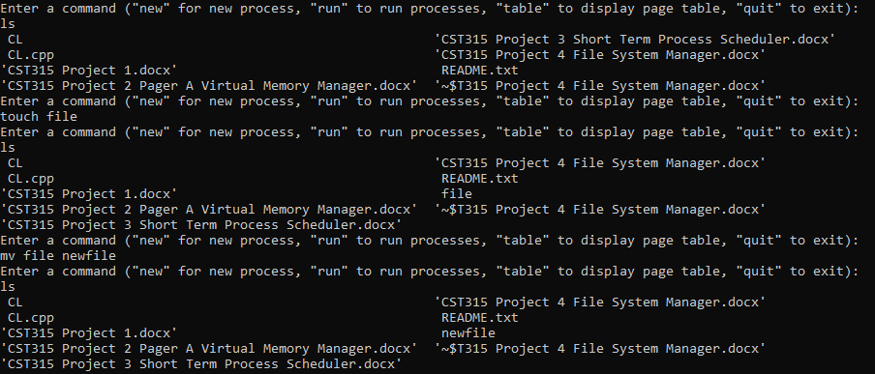

Editing a file: 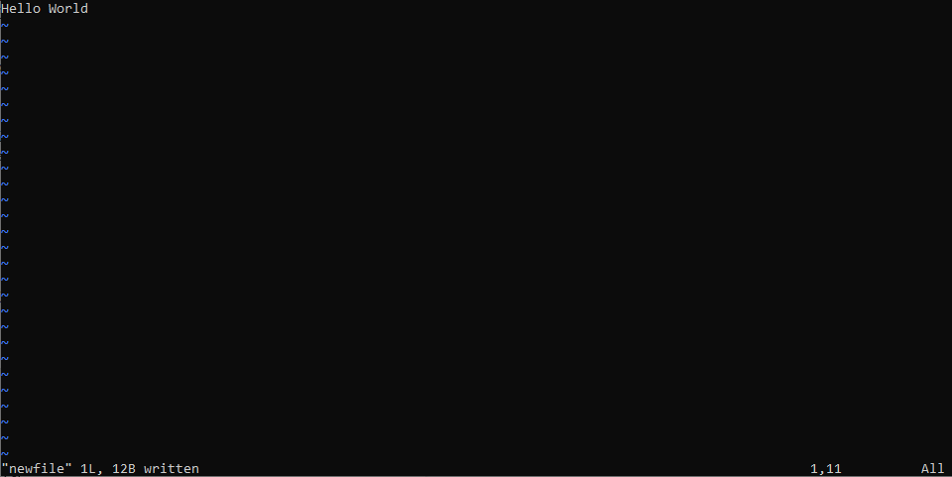

Deleting file and creating directory: 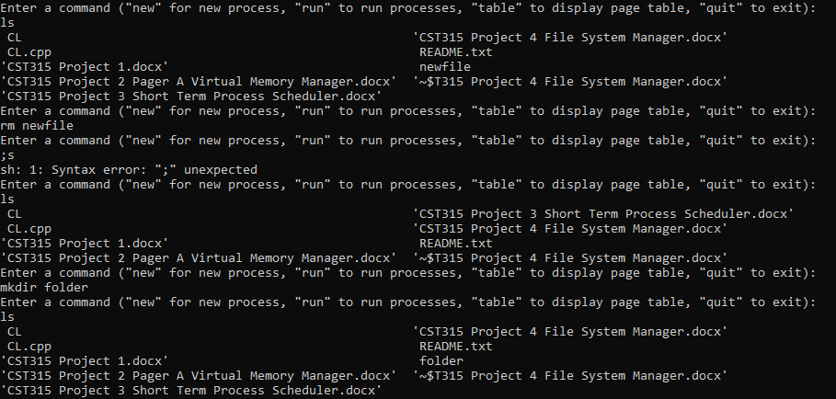

Moving file and deleting non-empty directory:

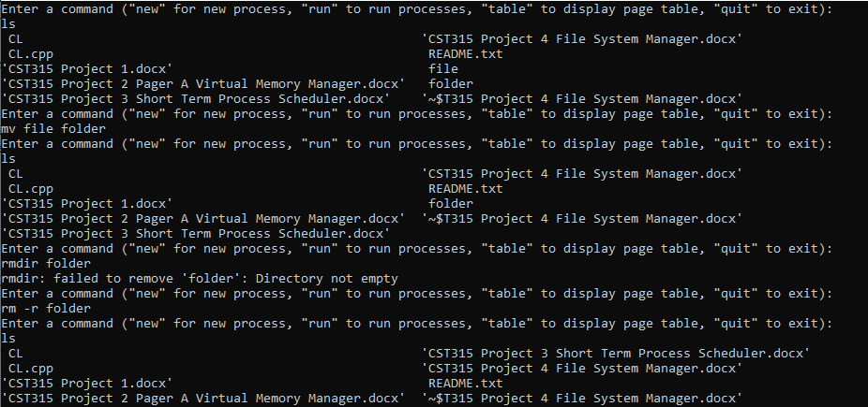

Rename and remove empty directory:

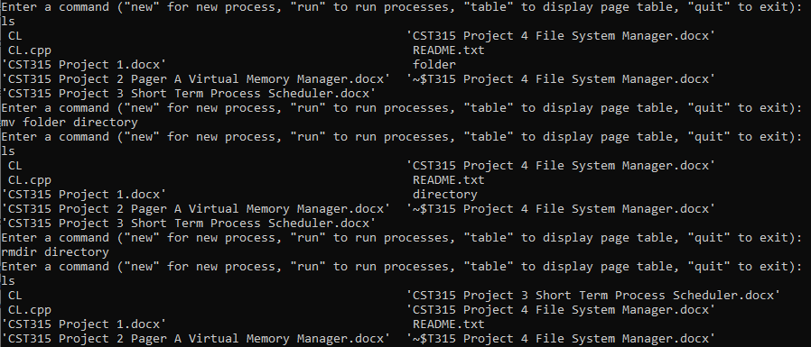

Duplicate files and directories:

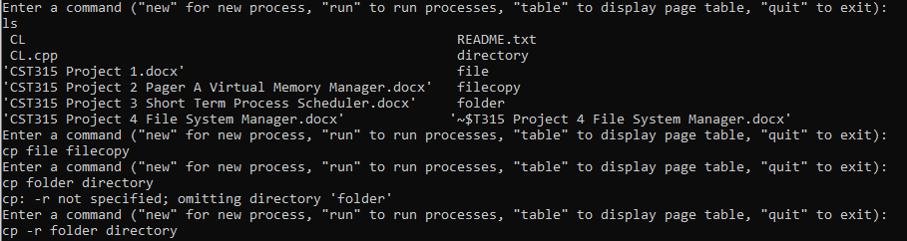

Display basic and detailed information about all files and directories in current directory:

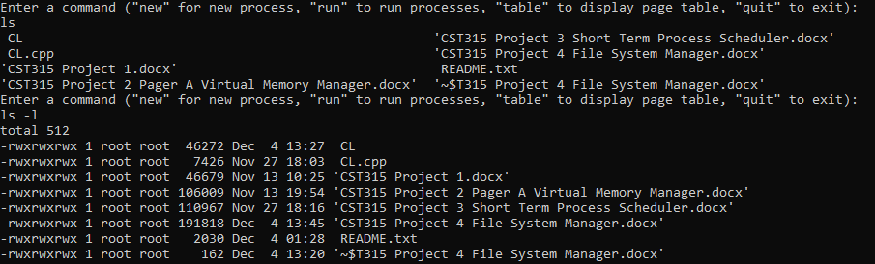

Find a file:



The program has no issues with executing.